Pet Show:
2016 CORN FESTIVAL WINNERS Congratulations!

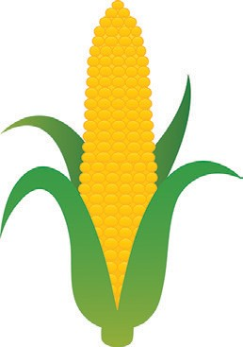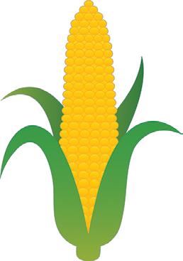Best in Show, Mikayla Dee with Melinda
Pet & Owner Look-Alike, Savanna & Rella Doctor with sarafina
Cutest Puppy, Mikayla Dee with Melinda Most Handsome Pet, Krista Myers with Wyatt Prettiest Pet, Austin Hartgrove with Paige Cuddly Cat, Ella Archabald with Ruby Kaye Most Unusual Pet, Selena Johnson with Jack Sports Costume, Zak Bake with Daisy
Best Costume, Leo Russo with Lugi

Corn King:
1st Alan Henry
2nd Henry Agle and Sons
3rd Amos Zittel and Sons

Corn Eating Corn Husking
1st Austin Hardtgrove 1st Layla Nemec
2nd Karlie Vinovski 2nd Raylan Bottsford
3rd Marco Alvarez 3rd Cole Walden

6-10 Years Old 6-10 Years Old
1st | Liam Schrecengost | 1st | Abby Winkelman
2nd | Ben Agle | 2nd | Shawn Erickson
3rd | Leila Montalvo | 3rd | David Malek

11-15 Years Old 11-15 Years Old
1st Joseph Pokigo 1st Olivia Coons
2nd Garrett Walker 2nd Donnie Winkelman
3rd Luke Flading 3rd Tristan Emhoff

Adult Adult
1st Mary Krone 1st Scott Telaak
2nd Jason Coones 2nd John Flading
3rd Scott Emhoff 3rd Jason Coones

Horse Shoes Corn Bread Baking
1st | Kevin & Cort Fry | 1st | Mary Krone
2nd | Rich Telaak & Dave Harms | 2nd | Samantha Curtis
3rd | Scott & Shawn

Corn Hole Corn Chowder
1st | Luke Murphy & Joe Hartman | 1st | Mary Krone
2nd | Aaron Felber & Pete Boldt
3rd | Peter Gabel & Justin Summers

Battle of the Bands
1st Turbulence

